<Document Title>

<Your Name>

<Student ID>

<Course Code>

<Professor Name>

<Due Date>

# Table of Contents

Table of Contents 2

Lab <n> - <Lab Name> 3

Part <n> 3

Description 3

Preparation 3

Observations 3

Screenshots 3

Reflection 3

References 3

# Lab <n> - <Lab Name>

# Task <1>

## Description

The network topology project entails creating and deploying a fiber-optic network that connects two buildings to form an organization's network infrastructure. The business headquarters and engineering/test departments, each with distinct departments and network needs, are located on the organization's main campus.

## Preparation

VLAN Definition: List the names of the VLANs and their functions for each department in the two buildings.

Inter-VLAN Routing: Set up routing to facilitate departmental communication inside the same structure.

Use access control lists, or ACLs, to manage departmental traffic flow and maintain security.

DHCP Setup: To enable dynamic IP addressing, set up DHCP servers for every VLAN.

Quality of Service (QoS): Set up policies to provide priority to traffic related to important applications.

Use the Spanning Tree Protocol (STP) to maintain redundancy and stop network loops.

Wireless Networks: Configure WiFi networks for visitors and employees that are appropriately secured.

Network Address Translation (NAT): To access the internet, set up NAT on the router.

VLAN Tagging: For VLAN segmentation, apply VLAN tagging to switch ports.

Testing: To guarantee appropriate functioning and connection, carry out thorough testing.

## Observations

For logical segmentation, VLANs need to be appropriately designed and linked to the departments for which they are intended.

While preserving security, inter-VLAN routing need to enable easy departmental collaboration.

It is important to properly establish ACLs in order to manage traffic flow and prevent unwanted access.

Within each VLAN, IP addresses should be assigned appropriately by DHCP servers.

To guarantee optimal performance, QoS regulations should provide priority to traffic related to key applications.

STP is supposed to keep the network stable and avoid loops.

Secure configuration of wireless networks is necessary to thwart unwanted access.

Internal devices should be able to access the internet via the ISP connection thanks to NAT.

In order to guarantee appropriate routing and traffic separation, VLAN tagging must be applied appropriately.

The complete network infrastructure's connection and operation should be confirmed through testing.

## Reflection

This organization's network topology design and implementation was a difficult but worthwhile experience that greatly improved my knowledge of and proficiency with network architecture. Every step of the project—from creating VLANs and setting up inter-VLAN routing to putting access control lists (ACLs) into place, setting up DHCP, establishing Quality of Service (QoS) policies, configuring wireless networks, implementing NAT, tagging VLANs, and conducting extensive testing—contributed to a comprehensive understanding of network design and management. This project was a crucial networking learning experience because of the careful planning and execution needed to satisfy the unique needs of each department while maintaining overall network efficiency and security. These efforts also yielded insightful knowledge about the deployment of network infrastructure in the real world.

# task <2>

## Description

The assignment involves setting up a company's main office and engineering/testing building's network topology in Packet Tracer. Routers (2911), switches (2960 for access, 3650 for distribution), and a few PCs as endpoints must be configured. Certain guidelines should be adhered to, such as having different switches for data centers, bonded channels for connections, and a router connected to the distribution switch of the main office for internet access. It's about ensuring that everything is correctly linked and functions as required for the network configuration.

## Preparation

Compile the necessary network elements in Packet Tracer: generic PCs, edge/access switches (2960), distribution switches (3650), and 2911 routers.

Arrange the topology's configuration, taking into account the specifications, including the quantity and positioning of switches, routers, and endpoints.

Observe the naming guidelines for network devices, making sure that the final four digits of the Condor ID come after the first four characters.

Set up bonded channel connections between distribution switches and edge switches, as well as between edge switches.

Assemble links between switches and routers in accordance with the topology specifications; don't forget to connect to the ISP router to get internet access.

## Observations

Check that the names of all network devices accurately reflect the naming scheme based on the Condor ID.

Verify that link aggregation and redundancy are configured correctly for bonded channel connections.

Verify that the devices are connected to each other and that the edge switches are connected to the appropriate distribution switches and routers in the correct ways.

Verify that the distribution switch in the headquarters building is linked to the router that offers internet connection.

To make sure that traffic flows appropriately in accordance with the topology design, test device connection and communication.

## Screenshots

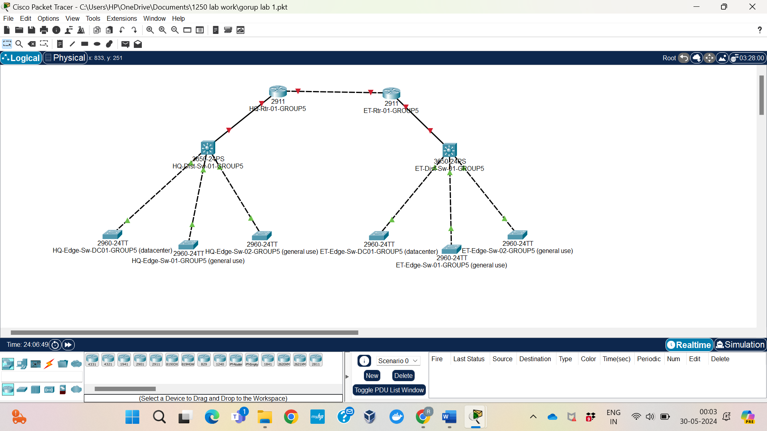

## Reflection

Creating the network topology in Packet Tracer gave me first-hand experience converting the specifications for network architecture into a workable implementation. A crucial component of the endeavor was setting up bonded channel connections and adhering to the naming guidelines, highlighting how crucial precise device naming and network connectivity are. The method demonstrated the complexities of network design, such as appropriate device location, connection planning, and functionality and reliability testing. Overall, utilizing simulation tools like Packet Tracer to design and build network topologies improved my abilities.

## Part <3>

## Description

This task is supposed to determine the VLANs required based on the given requirements and configure them on all switches.

## Preparation

* Assign unique VLAN IDs for each department, Wi-Fi, and datacenter.
* Configure VLANs on all edge and distribution switches.

## Observations

In this task during configuration of VLANs for the network topology many points are important. First, each site requires VLANs tailored to its specific needs, such as departmental separation, dedicated datacenter VLANs, and Wi-Fi VLANs for staff and guests.

Moreover, proper VLAN naming is important for maintaining clarity. Apart from that, the task involves configuring VLANs on both edge and distribution switches and enabling trunk on inter-switch links to facilitate the passage of VLAN traffic. It's essential to assign at least one port to each VLAN on every edge switch within their respective buildings to ensure that devices can connect to the appropriate network segments.

## Screenshots

1. Configuration VLANS on all edge and distribution on all switches.

1. Setting up trunk links on switches.

## Reflection

In reflection, to ensure successful VLAN configuration, it’s crucial to follow a systematic approach that includes defining VLANs, configuring ports, and setting up trunk links. Proper naming conventions and adherence to best practices for unassigned ports will ensure network segmentation and security.

Apart from that, the configuration steps were straightforward due to the clear requirements and naming conventions. Ensuring that each VLAN is correctly named and assigned makes future troubleshooting and management more efficient.

# Lab 1

# Part <5>

## Description

This tasks involves creating a Link Aggregation Control Protocol(LACP) bonded channel,, which combines multiple network connections into a single link. This bonded channel will have 2 interfaces and will be established between the interconnected switches. Additionally, Virtual Local Area Network (VLAN) Trunking will be configured as required, allowing multiple VLANs to share the same physical link.

## Preparation

* Identify the switches that need to be interconnected.
* Determine the physical ports on each switch that will be used for the bonded channel.
* Ensure that the switches support LACP and VLAN Trunking.
* Gather the necessary configuration commands for my switch model and operating system.

## Observations

* Access the configuration mode on each switch.
* Create the LACP bonded channel by specifying the ports to be included in the channel.
* Configure VLAN Trunking on the bonded channel, allowing multiple VLANs to traverse the link.
* Verify the configuration by checking the status of the bonded channel and VLAN Trunking.
* Capture screenshots of the relevant configuration and status information on each switch.

## Screenshots

## Reflection

* Firstly, I Reviewed the captured screenshots to ensure that the bonded channel and VLAN trunking are configured correctly on each switch.
* Then Analyze the output to confirm that the bonded channel is operational and that VLAN trunking is enabled.
* If any issues are identified, then I troubleshoot and make necessary adjustments to the configuration.
* Then I document the entire process, including challenges faced and the solutions implemented.
* Consider any potential improvements or optimization that could be made to the configuration for between performance or redundancy.

Part 6

Description:

OSPF should be set up to route packets among VLANs. For this reason, OSPF routers are going to be set up on distribution switches that service Inter-VLAN Routing (IVR). OSPF Designated Router (DR) will be housed in the main office building distribution switch. You may choose any value from zero through 255 or 1 through 254 but it is important to stay on last for the circuit subnet. In order to implement OSPF between VLANs, all the tasks need to be planned and carried out in terms conducive to configuration efficiency.

Preparation:

* Identify Network Requirements.
* Configure the switches and routers accordingly.
* Cisco switches and routers for configuring VLANs and OSPF.

Observations:

It was simple and informative to configure Inter-VLAN routing using OSPF. Defining VLANs, as well as assigning IP addresses, required one to be meticulous. By using the last two digits of the Condor ID, we guaranteed consistency. To ensure stability, we made the headquarters switch to the OSPF Designated Router (DR) with a priority of 255. The right OSPF neighbor establishment and route propagation checks were carried out by means of `**show ip ospf neighbor**` together with `**show ip route**` commands. Initial misconfigurations were resolved by a careful review, stressing the significance of thorough planning and the use of confirmation in building a strong network while the system displayed fast convergence and effective redundancy.

Reflection:

Setting up OSPF for Inter-VLAN routing offered us hands-on experience on how to configure Vlans and ospf. It served as a way of emphasizing the need for careful planning and verification at every point so as to have a working efficient network. We made sure that our HQ distribution switch was acting as DR, so we had OSPF network topology that was stable and predictable. It helped us understand that there is need for backup and good design of network architecture for the sustenance of networks.

# Part <7>

In Task 7, the objective is to configure the headquarters building router to provide access to the Internet for all VLAN networks using OSPF for internal routing and static routing for external connectivity. This configuration involves setting up routing protocols and ensuring proper network connectivity between internal VLANs and external networks via the ISP router.

DESCRIPTION:

Task 7 concludes with the headquarters building router effectively configured to manage internal routing using OSPF and direct external traffic via static routes to the ISP router. This setup ensures seamless communication between VLAN networks within the enterprise and access to the Internet, meeting the operational requirements specified in the assignment.By following these steps and documenting the configuration process comprehensively, you establish a robust network infrastructure that supports both internal communication and external connectivity essential for organizational operations.

**Observation**

During the configuration of Internet routing:

* **Routing Protocol Selection:** OSPF is chosen for internal routing within the enterprise network due to its dynamic routing capabilities, which can efficiently handle changes in network topology.
* **Static Routing for Internet Access:** A static route is configured on the headquarters router to direct traffic destined for the Internet to the ISP router’s IP address (211.212.xx.49).
* **Network Testing:** After configuring the routing, various VLAN networks are tested to ensure they can reach external destinations on the Internet. Ping tests and traceroutes are performed from different VLANs to verify connectivity.

Preparation

To prepare for Task 7:

Review Network Topology: Understand the layout of the network, including VLAN assignments, router configurations, and connectivity requirements.

Configuration Plan: Develop a detailed plan for configuring OSPF on the distribution switches and static routing on the headquarters router. Ensure IP addressing is consistent and matches the assignment requirements.

Documentation: Prepare to document each configuration step thoroughly, including screenshots of configuration commands and routing tables to demonstrate successful implementation.